*Florida International University*

*School of Computing and Information Sciences*

Software Engineering Focus

Feature Document

User Story ID <NVOS-23 View Profile>

**Name:** Andrew Castillo

**Team Member(s):** Andrew Castillo

Bryan Bastida

**Project:** Envo Scholar

**Product Owner(s)**: Mark Finlayson

**Mentor(s)**: Masoud Sadjadi

**Instructor**: Masoud Sadjadi

**User Story Name:**

* Description: As a user, I want to view my own profile, so that I can see my searches and results.

Acceptance Criteria

* User clicks on Sign In
* Login page opens
* User fills out credentials and clicks Login
* User is now able to view their profile

**Use Case**

* Name: NVOS-23 View Profile
* Actor: User, Webpage, and Firebase database
* Preconditions: User has logged into their account
* Description <Flow of events>: User clicks on Sign In

User fills out login credentials

User clicks Login

User is presented with their page

**Use Case Diagram**

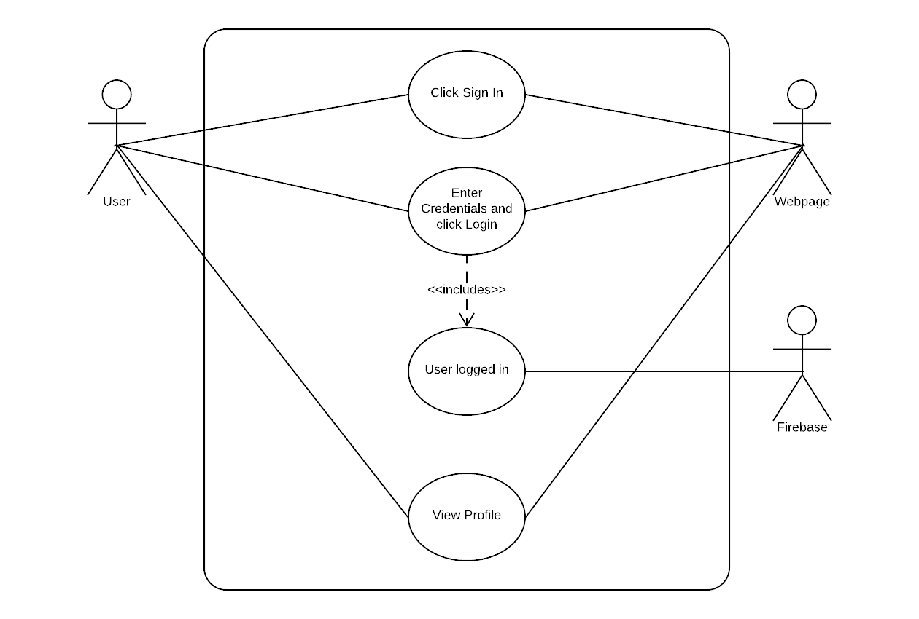

**Sequence Diagram**

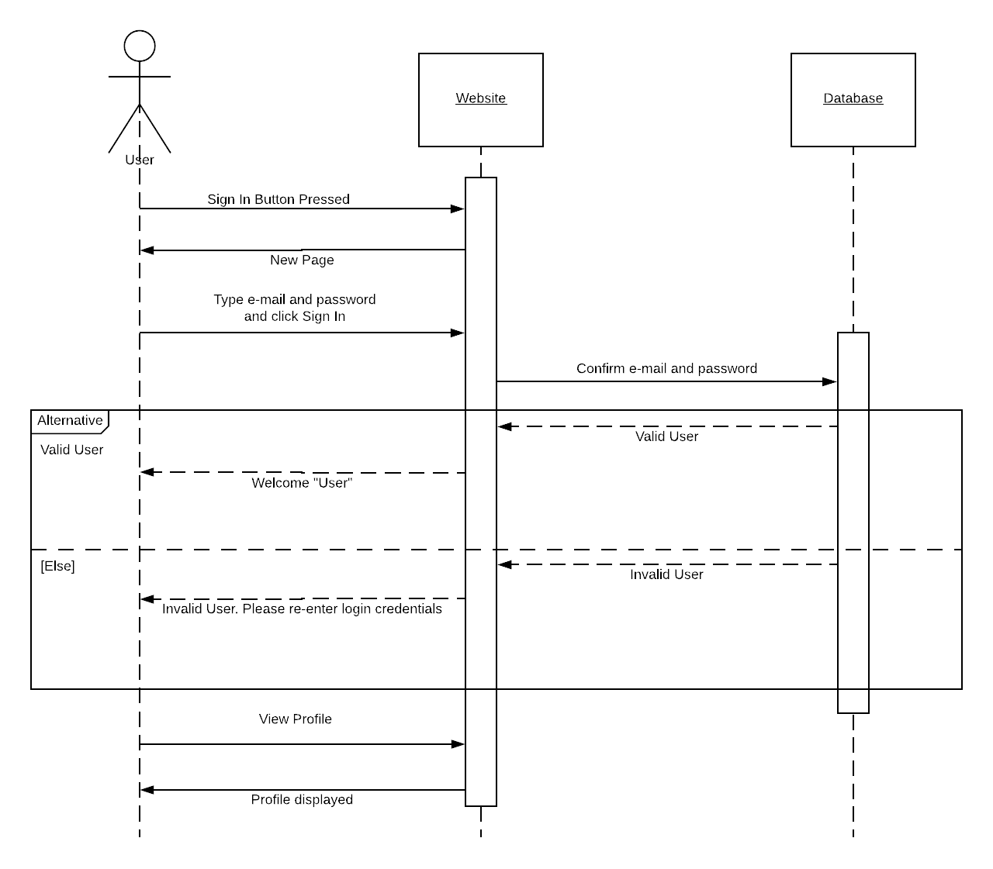  
**Class Diagram**

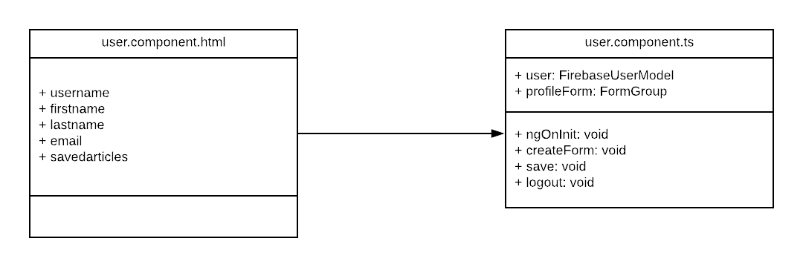

**Unit Test**

* Test case ID: NVOS-23-View-Profile
* Description/Summary of Test: This test was made to check if a user can view their profile
* Pre-condition: User has entered login credentials
* Expected Results: User will be taken to their profile after hitting login
* Actual Result: User is taken to their page after hitting login
* Status (Fail/Pass): Pass

**Visual User Guide**